Proceedings of the Solar Thermal Energy Design Course
MECH9720
12 May, 2017, Sydney, NSW, Australia

z5096539

absorption cooling powered by solar thermal energy

Jonard Delos Santos
School of Mechanical and Manufacturing Engineering,
The University of New South Wales
Kensington, NSW 2052, Australia

Abstract
A review of the solar absorption cooling system is presented in this paper. The key components of the said system are the solar thermal collectors, absorption cooler and the working solution. Three most common type of thermal collectors is scrutinized and found that parabolic trough collector is the most efficient. The LiBr-water mixture is preferable working pair in the solar cooler over water-ammonia because of its many advantage in terms of COP and safety. Also, the different types of absorption chillers is looked into namely single, double and triple effect as well as the less popular GAX chiller. Lastly, to address the issue on reducing the reliance on non-solar thermal energy in absorption cooling system, a storage system that store latent heat is proposed using phase change material.

1. INTRODUCTION

The rapid industrialization and urbanization in worldwide, particularly in Asia, has increased the energy demand unprecedently which is expected to reach a total world energy consumption of 815 quadrillion Btu in 2040[1]. The buildings sector accounts for 20.1% of this which includes energy used for heating and cooling. In response to this, researches are gearing towards finding cheaper and environment-friendly and creating efficient system to minimize the consumption. In relation to this, solar technologies are being considered as potential alternative to address the issue abovementioned. One of the solar technology that can be applied both for industrial and residential sector is the solar absorption cooling system.
In this report, the concept of common solar absorption cooling technology is discussed and will focus on the three key components namely; solar collectors, absorption chiller and working fluid. With relation to this, recent development of the said technology and its effect on improving its efficiency is presented. Finally, to further utilize the excess solar thermal energy harvested by the collector, the use of latent heat storage system is presented.
2. Nomenclature

COP coefficient of performance
CPC compound parabolic collector
DNI direct normal irradiance
ETC evacuated tube collector
FPC flat-plate collector
GAX generator-absorber heat exchange
PCM phase change material
PTC parabolic trough collector
LiBr lithium bromide salt
3. system description

Absorption cooling is a type of cooling system that is running on thermal energy supplied externally and in the case of the solar absorption cooling system, the source of heat is the sun. In some aspects, the solar absorption cooler is similar with the traditional refrigeration/ air-conditioning unit since it is composed of the same major component like the condensing unit, evaporating unit and throttling device. The main difference is that the compressor, which increase the pressure of the refrigerant and to vaporized it completely, is replaced with the absorption reservoir and generator as shown in Figure 1[2].
In addition, the refrigerant is replaced with a mixture of pair working fluid; an absorbent and a refrigerant. Other key components of the system are transfer pumps, and of course the solar collector.
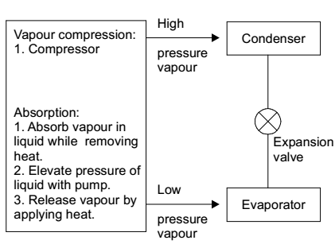
Figure 1: Comparison between traditional vapour compression cycle and the absorption cooling system[3]

Figure 2 shows the schematic of a solar absorption cycle. In the absorber, the working solution is pumped and initially heat up as it crossed the heat exchanger then proceeds to the generator for final heating. The solar collector will heat up the secondary working fluid which is typically water. This secondary working fluid is supplied to the heat exchanger integrated to the generator which heats up the main working fluid inside it. Note that in Figure 1, the system is equipped with storage tank for the secondary fluid which is commonly used and is usually equipped with auxiliary heating feature to cope up with the demand of the generator in the event of low solar irradiation. As the absorbent-refrigerant mixture is heated up, the more volatile refrigerant is vaporized and is segregated from the absorbent. The separated absorbent will return to the absorber passing a heat exchanger and expansion valve where it is cooled down and depressurized respectively. The refrigerant will proceed next to the condenser where it will release heat to change phase back to liquid. Then it will pass through a throttling device to reduce the pressure. Finally, the refrigerant will again undergo a phase change to vapor by absorbing heat from the space being cooled before it returns to the absorber where it is mixed back with the absorbent.
Among the technology that utilize solar energy for cooling, the solar absorption cooler is the most preferred due to its relatively high COP[5]. Other advantage of the solar absorption system is it can operate with low temperature and because of the omission of the compressor, the system has less vibration.
On the other hand, the efficiency of the solar absorption system is still not at par with the traditional vapour compression cycle cooling system. Additionally, the initial cost is also high which is the reason why it is not yet widely used. With regards to the refrigeration unit of the solar absorption cooler, the major drawback is that the temperature of the absorption chiller during operation has to be kept at a very narrow range[5].
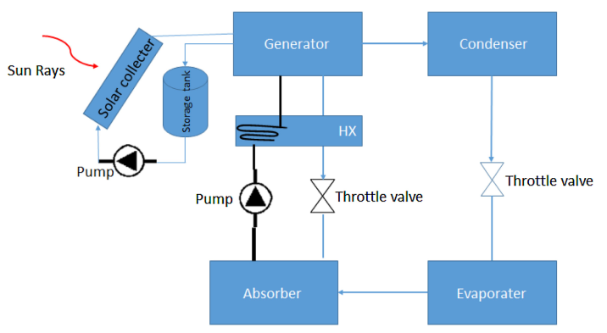
Figure 2: A diagram of solar absorption cooling system[4]
4. Performance metrics

The performance of the solar absorption cooling system can be quantified using solar fraction and coefficient of performance (COP)[6].
Solar fraction is employed for system where auxiliary heating is installed which is typical since the solar irradiation is not consistent and sometimes lower than the cooling system requirement. This is the ratio of the solar heat gain versus the total heat supplied to the cooling system(solar heat and auxiliary heat).
The COP is similar to the efficiency but is commonly used in refrigeration and cooling system. This is equal to the ratio of the heat absorbed in the evaporator to the heat supplied by the generator. The heat supplied by the generator is equal to the total heat from the sun and the auxiliary heating less the heat losses during heat transfer.
Some studies uses exergetic efficiency of the system which is based on the second law of thermodynamics[7].
5. Type OF COLLECTORS

In this type of cooling system, the solar thermal collector is the main component that is directly related to the technology of harnessing the energy of the sun. The collector functions by absorbing heat from the sun and transferring the thermal energy to the fluid that passed through it.
Bataineh et al. discussed the three common types of solar collector often used in solar absorption cooling system. These are the flat-plate collector, evacuated tube collector and parabolic trough collector[5].
5.1 Flat-plate collector

Flat-plate collector is the simplest one and is composed of cover (typically made of glass), absorbing flat plates, the tubes which serve as a channel for the fluid being heated and optional insulation layers to minimize heat losses due to transmission. An example of this installation is described in a paper about a study of the cooling system operating in Morocco[6]. In this study, they found that parameters directly related to the FPC in improving the overall performance of the cooling system are the collector tilt angle and the collector surface. At angle 10° and 20°, the FPC received lower solar irradiation on months January to March and October to December at around 4000kWh. However, on other months, particularly May to July, it receives the highest incident solar radiation, peaking at 9000kWh. This is the opposite for higher tilt angle of 50° and 60°. All through-out the year, the optimum angle of tilt is 30° and 40°. If the system is only use for cooling the building, such as in the case of air-conditioning unit, and if the angle of the tilt is fixed, the tilt angle which gives the highest solar radiation during summer season, namely 10° and 20°, is more preferred. However, if the system is use for refrigeration system, the optimum angle is more beneficial as it will give a more consistent supply of heat to the system. Note that this study is only conducted on one location and therefore the effect of the tilt angle may vary according to the geographical position of the installation[8].
The solar collector surface area is also analysed in this study and results show expectedly that the solar fraction is higher at higher surface area. The optimum surface area is found to be at 60m² with solar faction of 25%. Further increase in the surface area is not beneficial as it leads to overproduction of heat and increased initial cost.
Also, in the same study, the temperature of the inlet generator using the FPC ranged between 55-75°C (328.15-348.15K) which is suitable for single-effect absorption heat pumps which typically operates at relatively lower temperature than the multi-effect absorption temperatures.
5.2 Evacuated tube collector

Evacuated tube collectors are different from the FPC because it uses a heat pipe as fluid channel encapsulated inside a sealed tube under vacuum. This vacuum space leads to a more efficient solar collector as it minimizes the losses of heat due to convection and conduction[5]. An ETC powered solar absorption cooling system is designed and optimized for Malaysia is created by Assilzadeh, et.al[9]. The optimum tilt angle for an ETC collector with area of 15 m² is found to be at 20° which receives around 70,000 kJ of daily solar energy. The said system used auxillary heating once the temperature of the storage device goes lower than 80°C. The daily auxillary heating required versus the ETC area is analysed. It turned out that at starting at 35m² for a 3.5 kW cooler, the extra heating requirement becomes almost constant even if the area is increased. This means that the efficiency of the collector decreases as the area is increased beyond the optimum. Analogous to the case of the FPC, the solar fraction almost remain constant for collector bigger that 50m².
5.3 parabolic trough collector

For cooling requirement which requires higher storage tank temperature such as the case of multi-effect absorption cycle, the parabolic through collector can address this as it can produce heat at a temperature range of 50-400°C[10]. Parabolic trough collector is a type of concentrating collector which is made up of reflective material shaped into parabolic shape and installed with a receiver on its focal line. As the sun is directed to the PTC, all the beam radiation hitting the trough is reflected towards the receiver as shown in Figure 3. Since it can only work with direct solar radiation or DNI, a tracking mechanism is often installed to automatically adjust the position of the PTC.
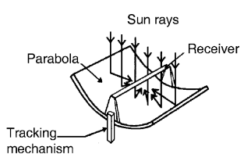

Figure 3: A diagram of PTC[10].

A solar absorption refrigeration system with PTC is proposed for use in cooling the ice-cream produces by a factory in Turkey[11]. At the same time, the same PTC will be use to supply heat for heating the ice cream mixture prior to cooling. The heating cycle of the ice-cream mixture is the stage 1 process and followed by the cooling which is stage 2. The proposed set-up is evaluated for its performance through numerical simulation using a computer program called EES using the actual data from the factory. The daily electrical energy consumption (heating and cooling) is calculated to drop from 85.81kWh to 1.235kWh which is 98.56% reduction in energy which is originally supplied by the electric grid if the system is implemented. The cooling COP of the absorption refrigeration system is calculated to be 0.7135 which is reasonable. Aside from this, the parametric analysis shown that the PTC length and area increases with the decrease in solar radiation intensity which is expected.
A comparative study, which is conducted by testing the FPC, ETC, CPC and PTC in a similar absorption cooler, shows that PTC is the most efficient among the three collectors employed in absorption cooling system[7]. It has a collector efficiency of 71.4% and cooling COP of 0.79588. This is followed by ETC with a collector efficiency and cooling COP of 65.65% and 0.7789 respectively. The least efficient is the FPC with collector efficiency of 42.47% and cooling COP of 0.7352.
5.4 other collector type

Other solar collector type can be used for the solar absorption cooling system like the CPC in the comparative study mentioned previously. The CPC or compound parabolic collectors are a concentrating type of collector which reflects all the incident radiation to the receiver (absorber) at a wider limit[10]. However, it has a poor collector efficiency of 46.04% and when used with the absorption cooling system, the cooling COP is 0.7578 which is inferior when compared with the performance of ETC and PTC. While its performance is slightly better than the FPC, the greatest drawback in using this type of collector is the initial cost which is the highest compared to the other three abovementioned.
Another type of collector, which is an improved version of FPC, is the flat-plate evacuated solar collectors. The key feature of this solar collector is derived from the ETC which is the used of high-vacuum space that serves as insulation to the water pipe therefore conserving the heat that might be diminished due to transmission. The experiment that utilized this new evacuated FPC is installed in Saudi Arabia with an area of 52.5m². This ultra-high vacuum FPC achieves a collector efficiency of more than 70% (46% median) with a cooling COP of 1.1. Note that this system utilizes a double-effect absorption chiller which may explain the very high COP compared to the three common collectors described earlier.
6. Working fluids

The working fluid which is discussed earlier is a pair of an absorbent and refrigerant. Do take note that this working fluid will only circulate with the refrigeration loop and is not the same working fluid use in the solar thermal collector. The most common absorbent-refrigerant pair used in solar absorption cooling system and is also the most widely studies is the water-ammonia pair and the LiBr salt-water mixture.
In the water-ammonia pair, the absorbent is water and the refrigerant, which is also more volatile, is the ammonia. According to Aliane., et. al, the water-ammonia working pair is not appropriate for use in solar absorption coolers because of the temperature it will require when feed to the generator (125-170ºC)[12]. However this is refuted by another study which suggest that the ammonia-water can be used with system that use GAX chillers with a COP of 0.8[13].
As for the LiBr-water mixture, the LiBr is the absorbent based on its relatively non-volatility compared to water. Water acts as the refrigerant in this working solution[12]. It is the most commonly use for the solar absorption cooling system with FPC or ETC as the thermal collector since this pair requires lower temperature, aound 80-100°C, in the generator than the water-ammonia pair[13].
The advantage of using the LiBr-water working solution versus the water-ammonia mixture are the following[3],[13]:
- The effect LiBr-water solution in the performance of the cooling system is higher COP than the water-ammonia.
- As mentioned earlier, the LiBr -water pair will require lower temperature of the generator thus making it more flexible in choosing the type of solar thermal collector.
- It requires a lower pressures and therefore lesser energy requirement for the pump
- Rectifier is often required to the ammonia-water system to ensure separation of the water and ammonia vapour which increases the complexity of the system.
- Ammonia is hazardous and therefore will require a more strict handling and safety feature in the system to avoid it from leaking.
- Water as the refrigerant in the LiBr-water pair is not contributing to the thinning of the ozone in the atmosphere.

Table 1: List of potential pair of working fluids for solar absorption cooling system[8].
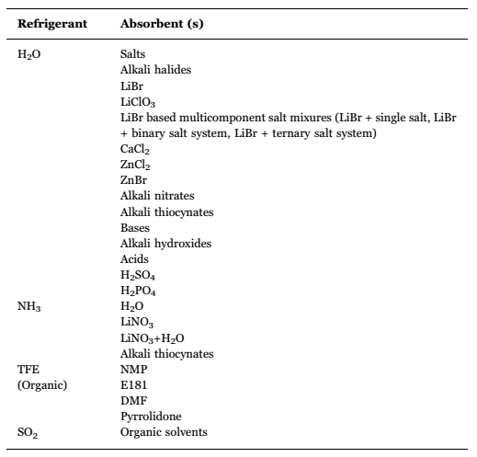

A recent study looked into another potential alternative working fluid for solar absorption cooling system using LiCl-water mixture[14]. LiCl is also another non-volatile chloride salt which act as the absorbent of water. The study examines the exergetic efficiency of the system by simulating a model of solar absorption cooling system running on LiCl-water pair and compare it with the on using LiBr-water solution. The results shows that the LiCl-water pair has higher exergetic efficiency leading to reduction in the solar collector area required to meet the heating requirement of the cooling system by 8%.
A comprehensive list of absorbent-refrigerant pair that can be used for the solar absorption cooling system is presented in Table 1.
7. Absorption chiller configurations
There are several types of absorption chiller and the most common installation use with solar thermal system are the single effect absorption cooler, two stage absorption cooling system and the generator-absorber heat exchange absorption cooler or GAX[4].
The most basic of all these cooler configuration is the one effect or single effect absorption cooler shown in Figure 2. This has 2 loops as described earlier: one of this is where the refrigerant will circulate doing the actual cooling by absorbing heat from the target that is being cooled. The other loop is for the transfer of the solution to the generator and the return line of the absorbent to the absorber chamber[3]. With this kind of system, the evaporator operates at temperatures of -30°C to -20°C while the generator temperature, which is being heated up by the solar thermal collector is running at temperature range of 80-110°C in which a COP of about 0.60 is attainable[4]. An example of study in using the single stage cooling system with the solar thermal technology is the case of the FPC solar absorption cooling system used in Morocco which is discussed earlier[6].
The two-stage or double effect cooling system is like a 2 circuit of single stage cooler put together as shown in Figure 4[8]. The components of the lower circuit are same with the single effect cooler and operates at lower temperature. In the upper circuit, the high-pressure generator will produce water vapor and is transferred to the generator in the lower pressure cycle. This will supply heat to the said generator in addition to the heat being supplied by the circulating water heated by the solar thermal collector. In the diagram shown in Figure 4, the refrigerant from the high-pressure condenser will proceed to the low pressure condenser. However, in some case, where there are only 1 condenser, the refrigerant will go directly to the evaporator of the lower circuit[4]. The advantage of this system, compared to the single effect cooling system, is that it can maximize the utilization of solar thermal energy and in effect will lower the reliance on third party source of heat. The COP of this system is around 1.2, which is substantially higher by almost twice of that obtained from single effect cooler. On the other hand, this system uses working liquids that require higher temperature in the generator which is more than 130°C[8].
In Universitas Indonesia, a hybrid of single and double effect solar absorption system was used in a facility that hosts laboratories, meeting hall, and classrooms[15]. The single-double effect absorption cooler has similar configuration with the two-stage absorption system except that this system can work in two modes depending on the cooling load requirements. During low cooling load, the system works like a single-effect utilizing only solar thermal energy from the 62 ETC integrated with it. When the time wherein the cooling load is high or when the collected heat from the sun is low, the system will shift to running in double effect cooling system wherein the high-temperature generator (high-pressure) is obtaining heat from a third-party source (gas-fired). The system claims to have an improved COP than the traditional double effect cooling system. At cooling water temperatures of 28-34°C and 75-90°C on the inlet of the hot water side, the COP is ranging from 1.4 to 3.3 and a reduction on the non-solar energy source (gas) by about 7% to 58%.
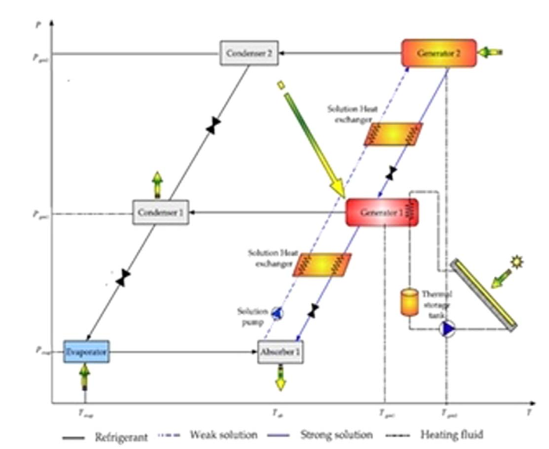
Figure 4: Typical set-up of the solar absorption cooling system with double effect cooler type[8].

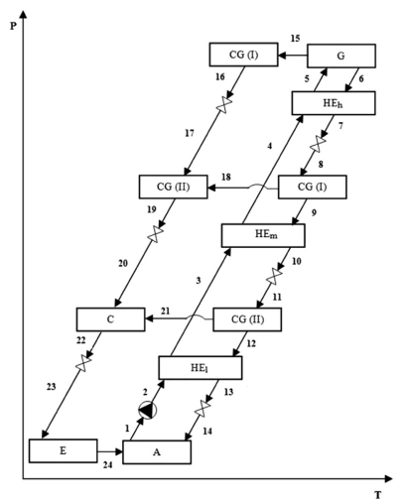
Figure 5: Flow diagram of the triple-effect absorption cooling system on a pressure-temperature diagram. The system is composed of evaporator (E), absorber (A), heat exchangers (HE_{l}, HE_{m} and HE_{h}), condenser-generator (CG-I and II) and generator (G)[16].

The triple effect absorption chiller is more closely resembling the single effect cooling system than to the configuration of the double effect chiller[16]. It is called triple effect because the refrigerant is separated from three different stages as shown in Figure 5. The refrigerant vapor is produced in the high pressure generator (G), the medium pressure condenser-generator (CG-I) and the low pressure condenser-generator (CG-II). The highest COP of, compared to the other previously mentioned chiller type, is obtainable by the triple effect cooler but with higher initial capital investment requirement[5]. Also, the use of solar thermal technology in this type of absorption chiller is scarce and the study is very limited as of this date.
In one study conducted by Shirazi et.al., wherein they simulated model of various set-up of solar absorption cooling system running on LiBr-water pair by changing the direct normal irradiance or DNI, they found out that there is no significant gain in using double nor triple effect chiller compared to single effect cooling system at lower solar beam radiation (DNI fraction of less than 60%)[17]. In addition, despite of the claim that multi-effect chillers have higher COP, the single effect cooling system will require less solar thermal collector area than the double and triple effect at the said condition. This however is different when the DNI fraction is above 60%. At this case, the collector area of the multi-effect chillers is significantly lower. To take advantage of this case, a hybrid system of the single and double effect cooler can be utilized which runs on different mode depending on the level of solar beam radiation. This concept is similar to the solar absorption cooling system used in Indonesia as described earlier.

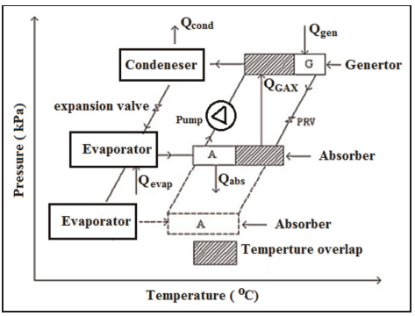
Figure 6: Flow diagram of the GAX absorption cooling system[5]

Another variation of the absorption chiller is the GAX absorption chiller[5]. In this system, there are two-pairs of evaporator-absorber working at medium and low pressure. In Figure xxx, the full lines correspond to the GAX circuit and the dashed lines is the single effect loop. The generator and the medium pressure absorber is held at same operating temperature by controlling the temperature and the concentration of the working fluid in the said component of the system. The effect of this temperature overlap is increase in COP. Similar to the triple effect cooling system, the application of solar thermal technology is very limited and can be a potential future research.
8. use of latent heat storage materials

The developments of the solar absorption cooling technology is moving towards the reduction of using non-solar thermal energy with the ultimate goal of full reliance on the power of the sun. However, since the solar radiation is not continuous and stable, like during cloudy days and at night time, this serve as a challenge for engineers to develop a system that runs completely on solar thermal energy. This can be possible though by employing a thermal storage system which will store the collected heat from the sun for later use at low solar radiation time. An example of such system is the use of latent heat storage material or more popularly called as phase change materials (PCM).
The latent heat storage materials is based on principle that a certain material will change phase when it absorb heat and by storing it in a thermally insulated tank or chamber, this material can supply heat to the absorption cooling system., i.e to the generators. A good and basic example of this is water, wherein steam is produced by utilizing the heat from the collector and storing it in an insulated tank. In the most recent review about the application of latent heat storage material in solar absorption cooling system, it is identified that the organic PCMs are more suitable for the solar chillers phase change temperature is inherently more stable [18]. In addition, the inorganic PCM are typically corrosive, exhibit phase separation and lacks the thermal stability that organic PC have. The drawback of using organic PCM though is naturally flammable and thus gives more challenge in creating a safe latent heat storage system and in handling the said material.
In an experimental study, the use of Erythritol PCM is used for storing the excess solar thermal energy with various type of heat exchanger is investigated. Results show that for cooling a house with 150m2 area, the quantity of PCM needed for 4 hours of space cooling is 238-242kg[19]. The ratio of the storage tank needed for this PCM compared to the water tank for sensible heating storage is between 0.1 to 0.25 which means that an additional benefit of using PCM is smaller storage space is required.

8. cONCLUSION

In this report, the concept of the absorption cooling system powered by solar thermal energy is presented. The main component which is directly related to the solar thermal technology is the solar thermal collector wherein 3 most commonly used type in absorption cooling system is identified namely; flat plate collector, evacuated tube collector and parabolic trough collector. Based on previous study, PTC is the most efficient among the three collectors when used in absorption cooling system as proven by its high collector efficiency and overall cooling COP. Then, two most widely studied working fluids are compared and these are the water-NH3 and LiBr-water. The latter proves to be the most favorable working solution for solar absorption cooling system as it gives better performance to the chiller, can be used in most type of collectors and is safe and environmentally friendly. Aside from this, the various configuration of absorption chiller configurations are looked into. Single effect turns out to be favorable for DNI fraction lower than 60% while the multi-effect requires less collector area at higher solar beam radiation. Finally, the use of latent heat storage material is evaluated for its applicability in the solar cooling system. The benefits of this technology is to maximize the use of solar thermal energy. In addition, study shows that the storage tank space requirement is lesser when PCM is use in lieu of traditional hot water tank.
Since majority of the studies are only based on model simulation, more experimental evaluation on a small scale is useful before fully implementing it. Additionally, a more comprehensive economic feasibility study is required indicating not only the savings cost but also the initial and maintenance cost for this system. While major application of the solar absorption cooling system is more on industrial scale, a study on micro-scale application of the said technology is also recommended as this can be a potential replacement to the conventional chillers and freezers currently used at home and in the supermarkets.
References

[1] “International Energy Outlook 2016 Liquid fuels,” 2016. [Online]. Available: http://www.eia.gov/forecasts/ieo/pdf/0484(2016).pdf.
[2] C. Carlson, M. Coulter, C. Kunkle, and P. Watson, “Solar absorption chiller,” Santa Clara University, 2014.
[3] T. N. Mittal V, Kasana KS, “The study of solar absorption air-conditioning systems,” J. Energy South. Africa @BULLET, vol. 16, no. 4, pp. 59–66, 2005.
[4] K. Bataineh and Y. Taamneh, “Review and recent improvements of solar sorption cooling systems,” Energy Build., vol. 128, pp. 22–37, 2016.
[5] K. M. Bataineh and S. Alrifai, “Recent trends in solar thermal sorption cooling system technology,” Adv. Mech. Eng., vol. 7, no. 5, pp. 1–20, 2015.
[6] Y. Agrouaz, T. Bouhal, A. Allouhi, T. Kousksou, A. Jamil, and Y. Zeraouli, “Energy and parametric analysis of solar absorption cooling systems in various Moroccan climates,” Case Stud. Therm. Eng., vol. 9, no. June 2016, pp. 28–39, 2017.
[7] E. Bellos, C. Tzivanidis, and K. A. Antonopoulos, “Exergetic, energetic and financial evaluation of a solar driven absorption cooling system with various collector types,” Appl. Therm. Eng., vol. 102, pp. 749–759, 2016.
[8] G. Leonzio, “Solar systems integrated with absorption heat pumps and thermal energy storages: state of art,” Renew. Sustain. Energy Rev., vol. 70, no. December 2016, pp. 492–505, 2017.
[9] F. Assilzadeh, S. A. Kalogirou, Y. Ali, and K. Sopian, “Simulation and optimization of a LiBr solar absorption cooling system with evacuated tube collectors,” Renew. Energy, vol. 30, no. 8, pp. 1141–1159, 2005.
[10] S. A. Kalogirou, Solar thermal collectors and applications, vol. 30, no. 3. 2004.
[11] O. Kizilkan, A. Kabul, and I. Dincer, “Development and performance assessment of a parabolic trough solar collector-based integrated system for an ice-cream factory,” Energy, vol. 100, pp. 167–176, 2016.
[12] A. Aliane, S. Abboudi, C. Seladji, and B. Guendouz, “An illustrated review on solar absorption cooling experimental studies,” Renew. Sustain. Energy Rev., vol. 65, pp. 443–458, 2016.
[13] D. S. Kim and C. A. Infante Ferreira, “Solar refrigeration options - a state-of-the-art review,” Int. J. Refrig., vol. 31, no. 1, pp. 3–15, 2008.
[14] E. Bellos, C. Tzivanidis, and K. A. Antonopoulos, “Exergetic and energetic comparison of LiCl-H 2 O and LiBr-H 2 O working pairs in a solar absorption cooling system,” Energy Convers. Manag., vol. 123, pp. 453–461, 2016.
[15] A. Lubis, J. Jeong, K. Saito, N. Giannetti, H. Yabase, M. Idrus Alhamid, and Nasruddin, “Solar-assisted single-double-effect absorption chiller for use in Asian tropical climates,” Renew. Energy, vol. 99, pp. 825–835, 2016.
[16] L. A. Domínguez-Inzunza, M. Sandoval-Reyes, J. A. Hernández-Magallanes, and W. Rivera, “Comparison of the performance of single effect, half effect, double effect in series and inverse absorption cooling systems operating with the mixture H20-LiBr,” Energy Procedia, vol. 57, no. 1–2, pp. 2534–2543, 2014.
[17] A. Shirazi, R. A. Taylor, S. D. White, and G. L. Morrison, “Multi-effect Absorption Chillers Powered by the Sun: Reality or Reverie,” Energy Procedia, vol. 91, pp. 844–856, 2016.
[18] M. M. A. Khan, R. Saidur, and F. A. Al-Sulaiman, “A review for phase change materials (PCMs) in solar absorption refrigeration systems,” Renew. Sustain. Energy Rev., vol. 76, no. April 2016, pp. 105–137, 2017.
[19] F. Agyenim, “The use of enhanced heat transfer phase change materials (PCM) to improve the coefficient of performance (COP) of solar powered LiBr/H2O absorption cooling systems,” Renew. Energy, vol. 87, pp. 229–239, 2016.

